Project 57 Documentation
Răduică-Boța Denis-Gabriel

Block Diagram:
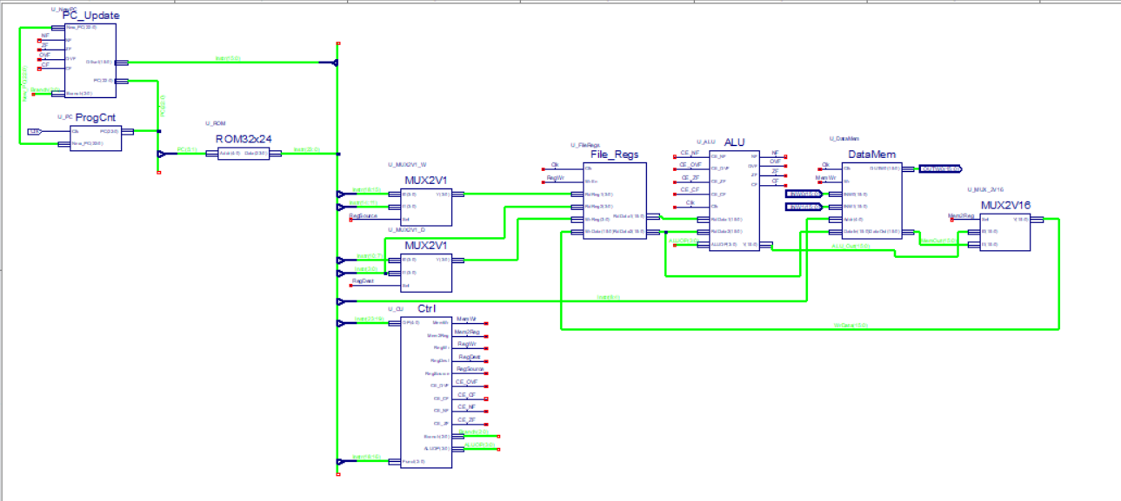
Implemented specific instructions:
SL Wb,Wns,Wnd 404
INC2 Ws,Wd 258
SUBB Wb,Ws,Wd 415
XOR #lit10,Wn 438

Explanation of the blocks:
ProgCnt (U_PC)
The Program Counter implements the basic program counter register that stores the current program counter (PC) value. It updates the PC with a new value (New_PC) on the rising edge of the clock (Clk).
PC is initialized with 0 at the start.
PC_Update (U_NewPC)
It calculates the next program counter value (New_PC) based on branching conditions, an offset, and flags. It handles branch decisions and computes the updated program counter accordingly.
It takes several flags as input (NF, ZF, OVF and CF) which are calculated in the ALU, and it uses them, together with the Branch vector to determine if and what Branch instruction to execute.
The Branch vector signal is an input which is sent from the Control Unit. Each value of Branch represents a specific branch instruction (“000” for unconditioned Branch, “001” for BRA OV, “010” for BRA C, “011” for BRA N, “100” for BRA Z).
When no Branch instructions are executed, New_PC simply takes the value of PC_p2, an internal signal which has the value PC+2, so it increments the current PC value by 2. However, when a Branch instruction is executed, New_PC will instead take the value of PC_p2 + Slit16.
Slit16 is an internal signal given by shifting the Offset input signal to the left once.
The Offset input signal is a 16 bit long vector which takes the value Instr(15:0), those bits being the offset of the jump.

ProgCnt sends the PC value to PC_Update, and PC_Update sends the New_PC value to ProgCnt.
ROM32X24 (U_ROM)
This block represents the ROM, having 32 locations with 24 bits each.
The memory is addressed using an input signal “Addr”, which takes the value of PC(5:1), and the array ROM, which contains the instructions, by converting Addr to an integer first.
The output will be “Data”, a vector of 24 bits, which is the extracted instruction from the ROM.

MUX2V1 (U_MUX2V1_W)
This is a simple multiplexer with 2 inputs of 4 bits and one selection input. This particular multiplexer determines the base register address from the instruction extracted from the ROM. The output will be sent to the File_Regs block.

MUX2V1 (U_MUX2V1_D)
This is an identical multiplexer, its use being to determine the destination register address from the instruction extracted from the ROM. The output will be sent to the File_Regs block.

File_Regs (U_FileRegs)
This is the general register block, containing 16 registers, W0-15.
It features two input vectors RdReg1, RdReg2 of size 4. RdReg1 is the input for the previously calculated base register address. RdReg2 meanwhile is the input for the source register address, and it’s taken directly from the instruction.
WrReg is a similar input vector meant for the previously calculated destination register address.
Reading is done using the internal signals RdData1_lcl and RdData2_lcl, which extract the operands from the registers, comprised by an array named s16Regs16 of 16 locations with 16 bits each. Afterwards, RdData1_lcl and RdData2_lcl assign their values to the RdData1 and RdData2 outputs respectively, thus having extracted the 2 operands.
Writing is done by assigning the input WRData to the location inside s16Regs16 given by the WrReg address on rising edges whenever the input WrEn is on.
This input is what dictates the writing operation.

WorkingRegister represents the content of the working register and it is determined by addressing the location given by WrReg. It is sent to the ALU for a specific instruction.

Control Unit (U_CU)
The CU is responsible for assigning values to signals. It has 2 inputs, OP, the OPCODE, and Funct, which is used for dinstinguishing Branch instructions from one another since they have identical OPCODEs otherwise.
The first signal is ALUOP, which is an encoding meant for the ALU. It decides which instruction the ALU should perform, each instruction being assigned its own unique ALUOP value.
Assigning the ALUOP is done based on the OP value, which is taken from the first 5 bits of the Instruction.
The next signal is MemWr, a simple signal which tells if a write to memory operation is to be performed.
Similarly, Mem2Reg tells if a load from memory to register operation should be performed.
RegWr is another simple logic signal that determines if the operation should write the result to a register. The few times this signal is 0 is when a Branch or load from memory instruction is executed.
RegDest is a signal that is used by the destination multiplexer as its selection input. This signal is 1 when the destination address is on the last 4 bits, otherwise it’s 0 for all other instructions.
RegSource is very similar in that manner, being used to determine the base register address in the other multiplexer previously described. It only takes the value 1 for a single instruction, otherwise being 0.
CE_OVF, CE_NF, CE_ZF and CE_CF are clock enable signals which allow the status of their respective flags (OV, N, C, Z) to be changed whenever the instructions which can change them are being executed. So, these signals have the value 1 when the instructions which can change their flags are being executed.

Funct is a vector of 3 bits taken from the Instruction, namely, the 3 bits after the OP. These bits are used to determine which Branch instruction is to be performed exactly. This input signal works with the Branch output vector signal, which designates an unique value for every Branch as mentioned in the PC_Update block.

Arithmetic and Logic Unit / ALU (U_ALU)
This module performs the operations of the non-branch instructions.
It has several inputs.
RdData1 and RdData2 are the operands extracted from File_Regs, each one 16 bits long.
ALUOP is the previously determined operation code. It is used to distinguish between the operations that the ALU will perform.
CE_NF, CE_OVF, CE_ZF, CE_CF are all the clock enable signals from the Control Unit. They will be used together with the Clk clock signal here in the ALU.
The result of the operation is the output vector Y, of 16 bits.
Lastly, the ALU also determines the values of the status flags NF, ZF, OVF and CF.
TenBitLiteral is an input vector representing the ten bit literal that is used in the XOR #lit10 instruction. It is taken directly from the instruction.
WorkingRegister represents the content of the working register. This content is extracted from File_Regs and sent to ALU. Used for the INC2 instruction.
As for internal signals, OP1 and OP2 are assigned the values of RdData1 and RdData2. These are our 2 operands.
We have an internal signal sY, which is a 17 bit vector. We use this extended vector to perform all of our operations here, the extra bit being important for determining things such as the Carry bit.
The result Y will take the value of sY’s last 16 bits (so skipping the first bit).
ShiftAmont is used to determine the shifting amount for the SL wb, wns, wnd instruction. It takes the last 5 bits of the second operand and converts them to an integer.

OP1_Aux is an internal vector signal that holds the value of the shifted operand.
Carry, Zero and Overflow are internal signals that are given the value 1 or 0 depending on whether they meet the conditions for turning on their respective associated flags. The values of these signals are assigned to the flag signals on the rising edge of the Clk clock and when their associated clock enable signals are on.
When assigning values to sY, a 0 bit is concatenated to the left of every used operand so as to match its size of 17.
NegCarry is the negated carry bit.

DataMem (U_DataMem)
This is the data memory block, having 16 locations of 16 bits each, and three more locations, INW0, INW1 and OUTW0.
The Wr input signal takes its value from the MemWr signal calculated in the Control Unit, working as an enable signal when data is written into the memory.
The Addr input vector takes its value directly from the instruction. Based on the most significant address bit of the address, it either fetches data from the memory or forwards external inputs.

MUX2V16 (U_MUX2V16)
This multiplexer with 2 inputs of 16 bits and one selection input decides which write data to send to File_Regs’ WrData input. It selects between storing the content of the result calculated in the ALU or the output of the DataMem block.

Instruction Table
Encoding | 2222  3210 | 1111  9876 | 111  5432 | 11  1098 | 7654 | 3210 | Flags
ADD | 0100 | 0www | wBqq | qddd | dppp | ssss | N, OV, Z, C
SUB | 0101 | 0www | wBqq | qddd | dppp | ssss | N, OV, Z, C
AND | 0110 | 0www | wBqq | qddd | dppp | ssss | N, -, Z, -
IOR Wb, Ws, Wd | 0111 | 0www | wBqq | qddd | dppp | ssss | N, -, Z, -
MOV f, wnd | 1000 | 0fff | ffff | ffff | ffff | dddd | none
MOV wns, f | 1000 | 1fff | ffff | ffff | ffff | ssss | None
BRA expr | 0011 | 0111 | nnnn | nnnn | nnnn | nnnn | None
BRA OV | 0011 | 0000 | nnnn | nnnn | nnnn | nnnn | None
BRA C | 0011 | 0001 | nnnn | nnnn | nnnn | nnnn | None
BRA N | 0011 | 0011 | nnnn | nnnn | nnnn | nnnn | None
BRA Z | 0011 | 0010 | nnnn | nnnn | nnnn | nnnn | None
SL Wb, Wns, Wnd | 1101 | 1101 | 0www | wddd | d000 | ssss | N, -, Z, -
INC2, Ws, Wd | 1110 | 1000 | 1Bqq | qddd | dppp | ssss | N, OV, Z, C
SUBB Wb, Ws, Wd | 0101 | 1www | wBqq | qddd | dppp | ssss | N, OV, Z, C
XOR #lit10, Wn | 1011 | 0010 | 1Bkk | kkkk | kkkk | dddd | N, -, Z, -

Control Unit Truth Table
Instr | OPCODE | ALUOP | RegSource | MemWr | Mem2Reg | RegWr | CE_NF | CE_Z | CE_OVF | CE_CF | RegDest | Funct | Branch
ADD | 01000 | 0000 | 0 | 0 | 0 | 1 | 1 | 1 | 1 | 1 | 0 | XXX | 111
SUB | 01010 | 0001 | 0 | 0 | 0 | 1 | 1 | 1 | 1 | 1 | 0 | XXX | 111
AND | 01100 | 0010 | 0 | 0 | 0 | 1 | 1 | 1 | 0 | 0 | 0 | XXX | 111
IOR | 01110 | 0011 |  | 0 | 0 | 1 | 1 | 1 | 0 | 0 | 0 | XXX | 111
MOV f, wnd | 10000 | 0100 | 0 | 0 | 1 | 1 | 0 | 0 | 0 | 0 | 1 | XXX | 111
MOV wns, f | 10001 | 0101 | 0 | 1 | 0 | 0 | 0 | 0 | 0 | 0 | 0 | XXX | 111
BRA expr | 00110 | 1111 | 0 | 0 | 0 | 0 | 0 | 0 | 0 | 0 | 0 | 111 | 000
BRA OV | 00110 | 1111 | 0 | 0 | 0 | 0 | 0 | 0 | 0 | 0 | 0 | 000 | 001
BRA C | 00110 | 1111 | 0 | 0 | 0 | 0 | 0 | 0 | 0 | 0 | 0 | 001 | 010
BRA N | 00110 | 1111 | 0 | 0 | 0 | 0 | 0 | 0 | 0 | 0 | 0 | 011 | 011
BRA Z | 00110 | 1111 | 0 | 0 | 0 | 0 | 0 | 0 | 0 | 0 | 0 | 010 | 100
SL Wb, Wns, Wnd | 11011 | 0110 | 1 | 0 | 0 | 1 | 1 | 1 | 0 | 0 | 0 | XXX | 111
INC2, Ws, Wd | 11101 | 0111 | 0 | 0 | 0 | 1 | 1 | 1 | 1 | 1 | 0 | XXX | 111
SUBB Wb, Ws, Wd | 01011 | 1000 | 0 | 0 | 0 | 1 | 1 | 1 | 1 | 1 | 0 | XXX | 111
XOR #lit10, Wn | 10110 | 1001 | 0 | 0 | 0 | 1 | 1 | 1 | 0 | 0 | 1 | XXX | 111

Simulation results

BRA Z
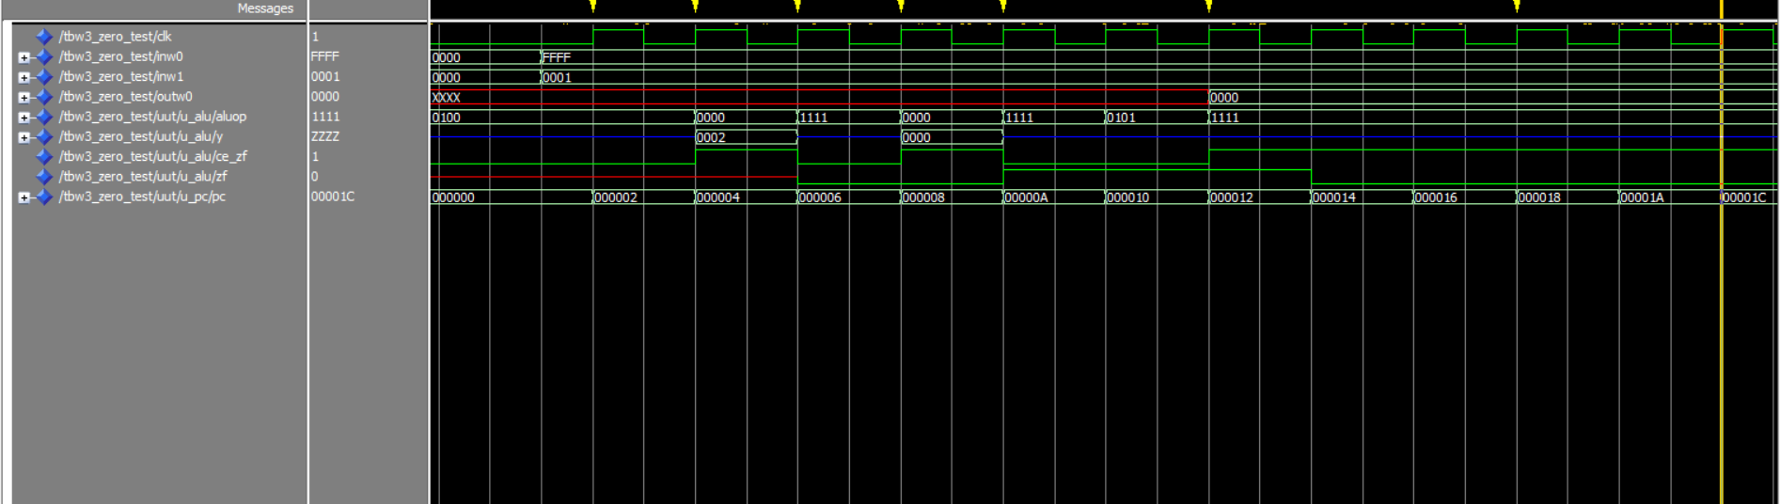
BRA N
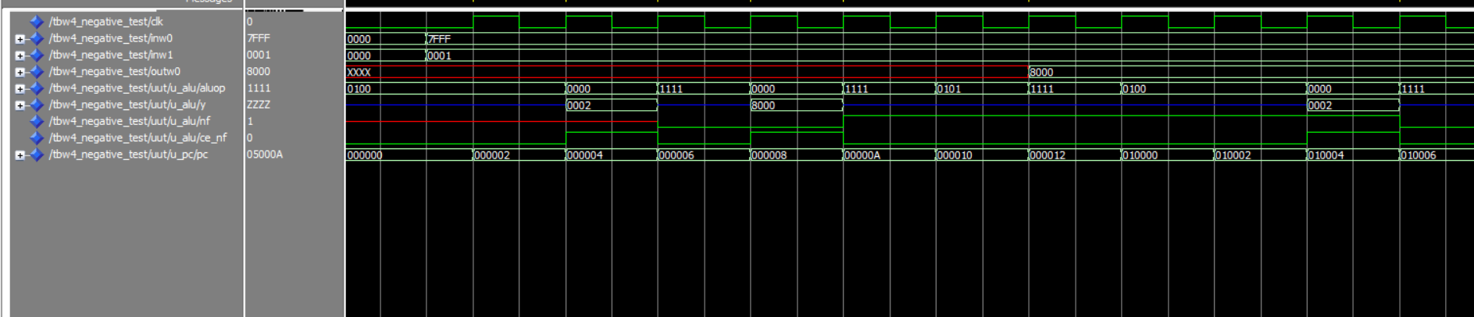
BRA C
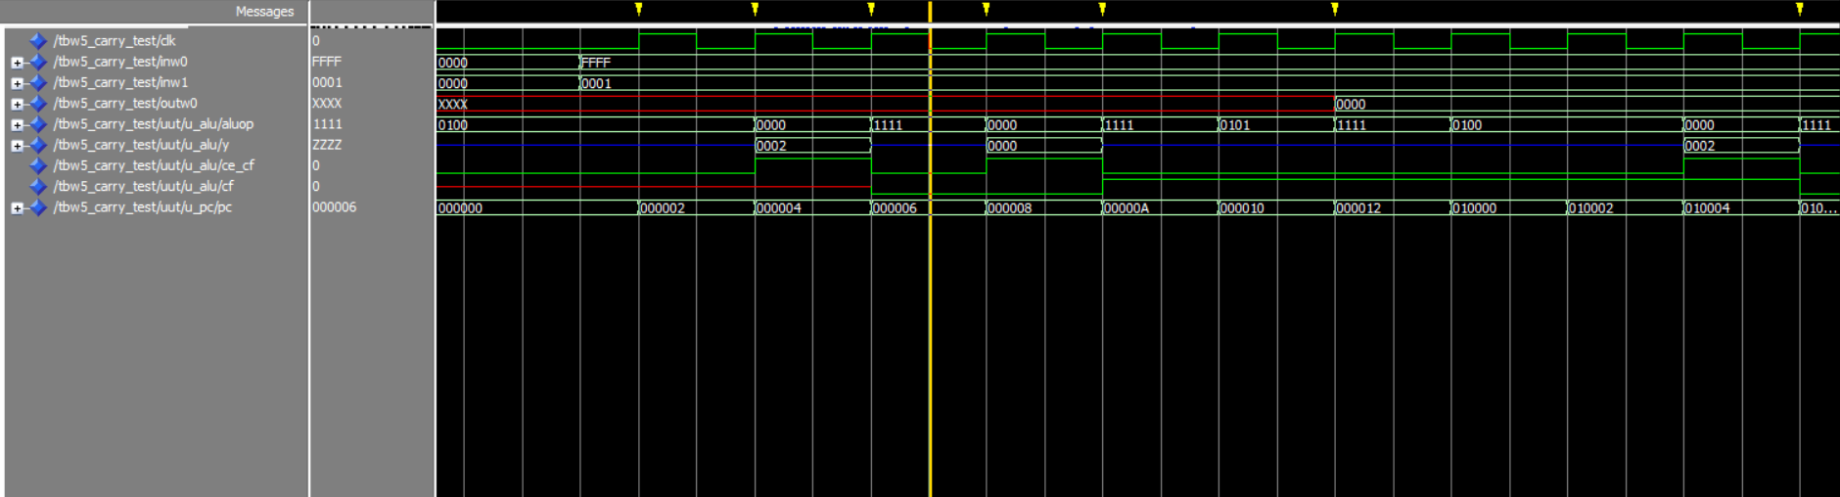

BRA OV
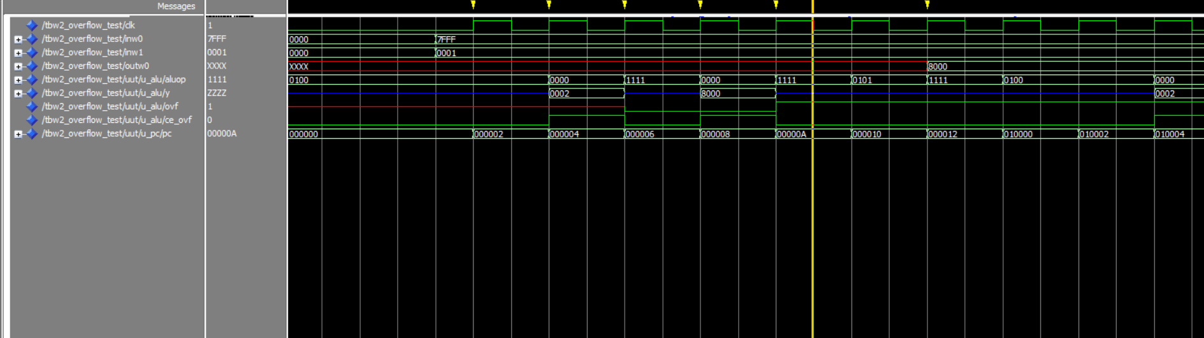
All Test
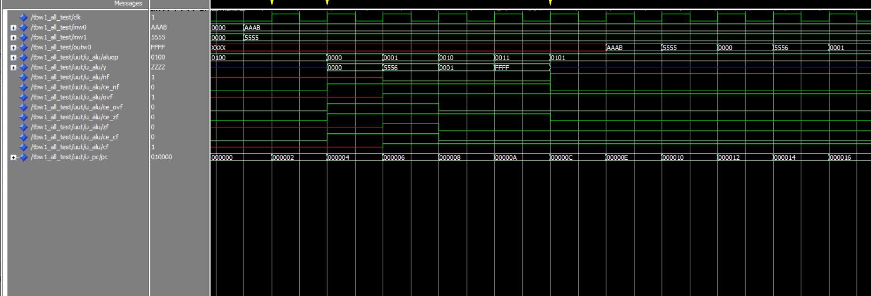
Zero Test
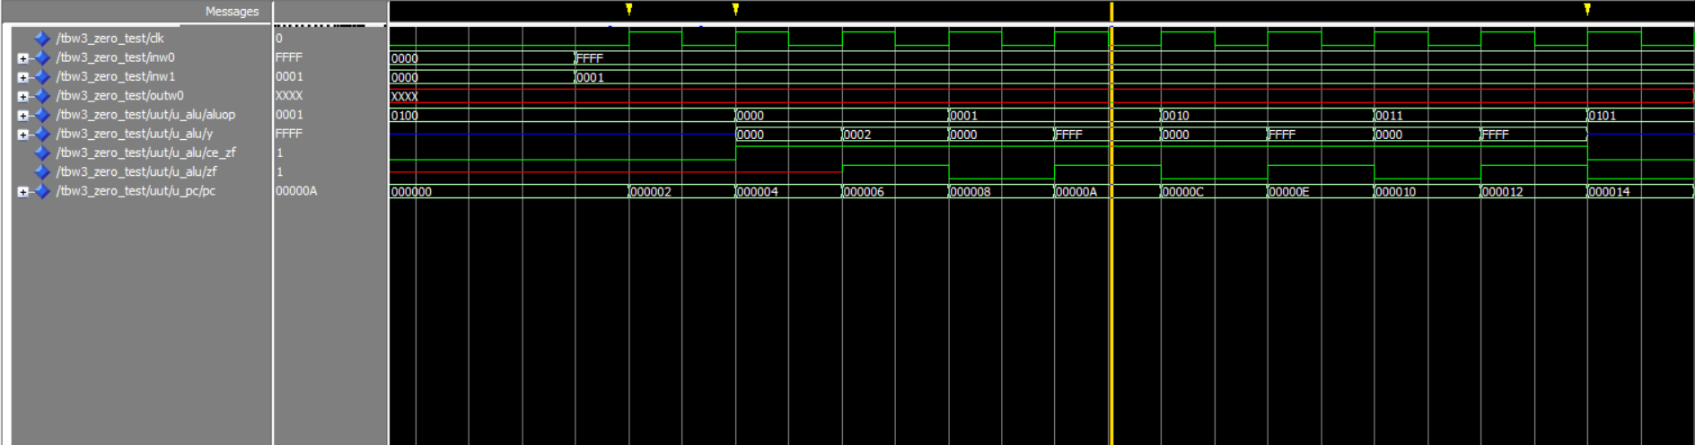

Negative Test
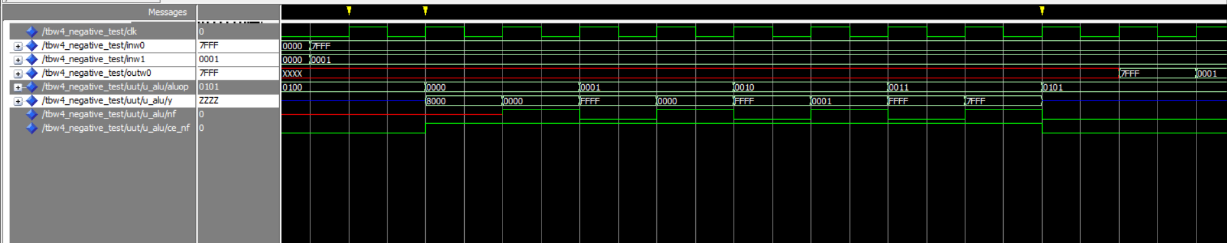
Carry Test
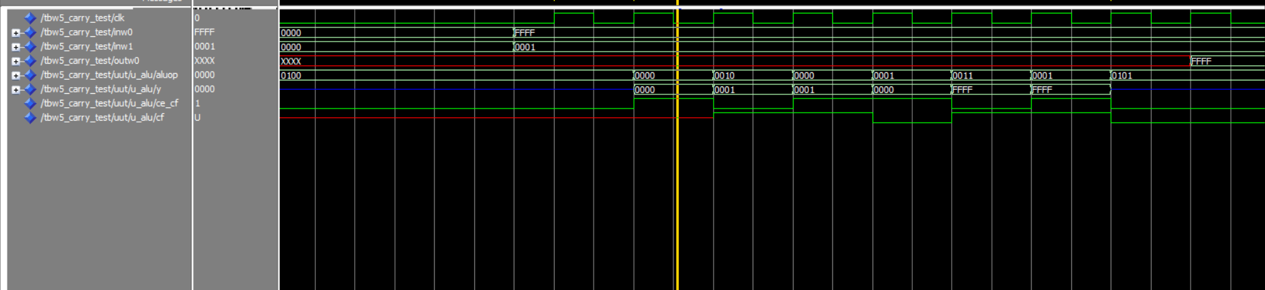
Overflow Test
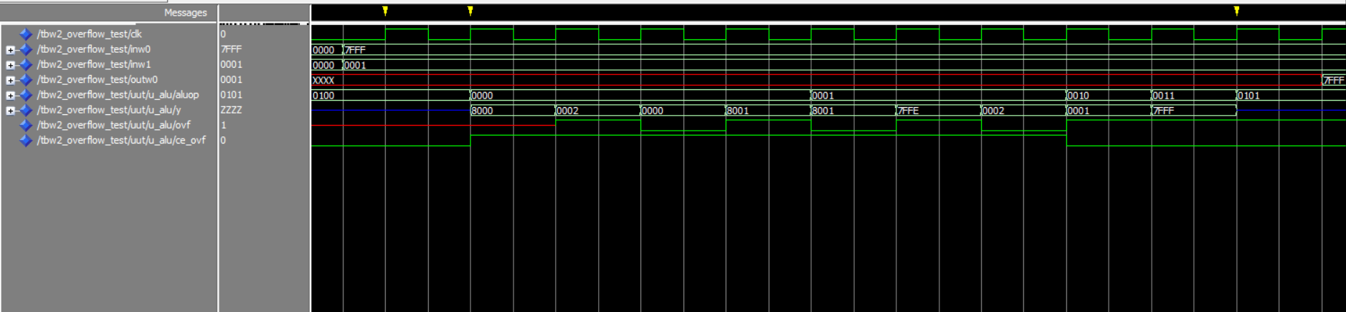
SL wb, ws, wnd
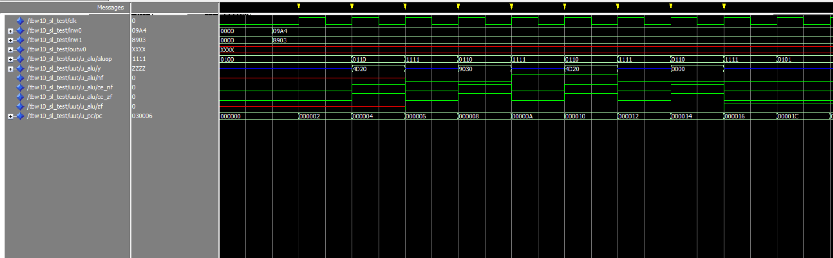

INC2 Ws, Wd
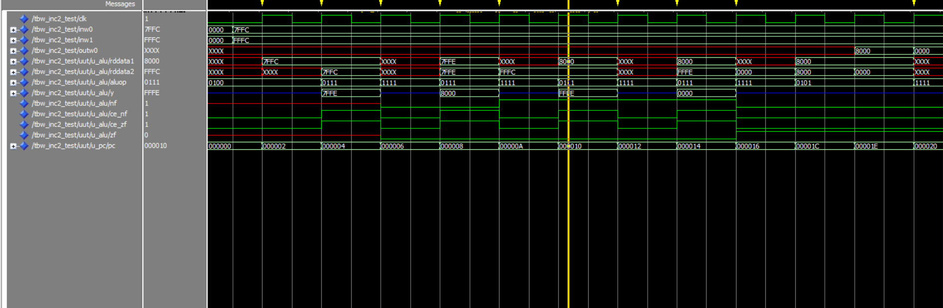
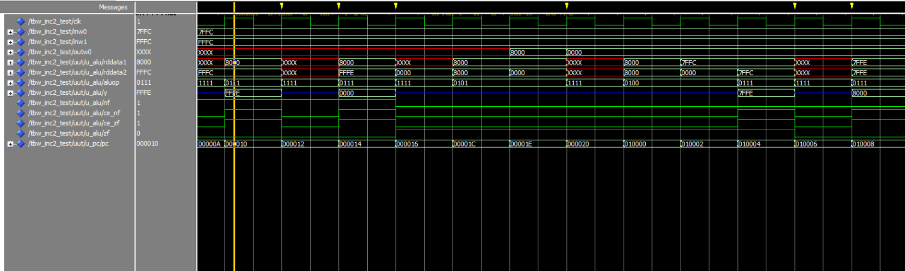
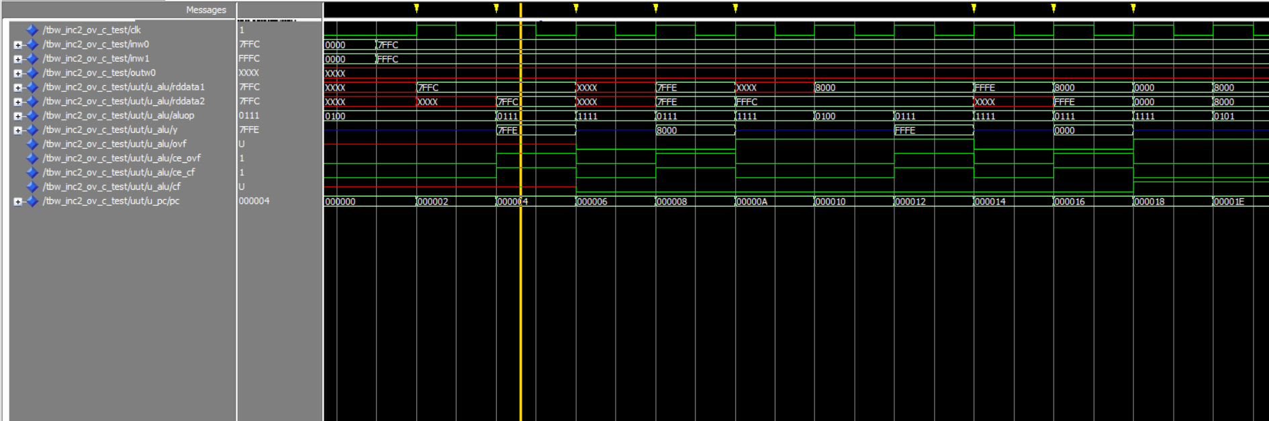
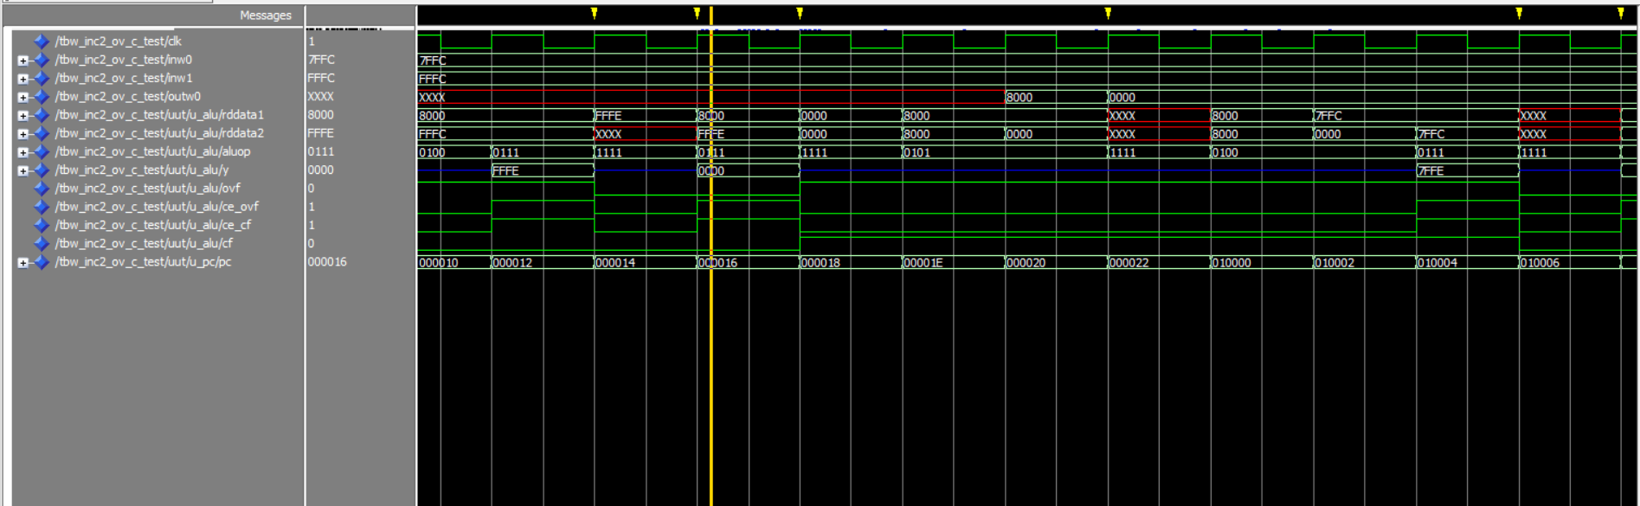

XOR #lit10,Wn
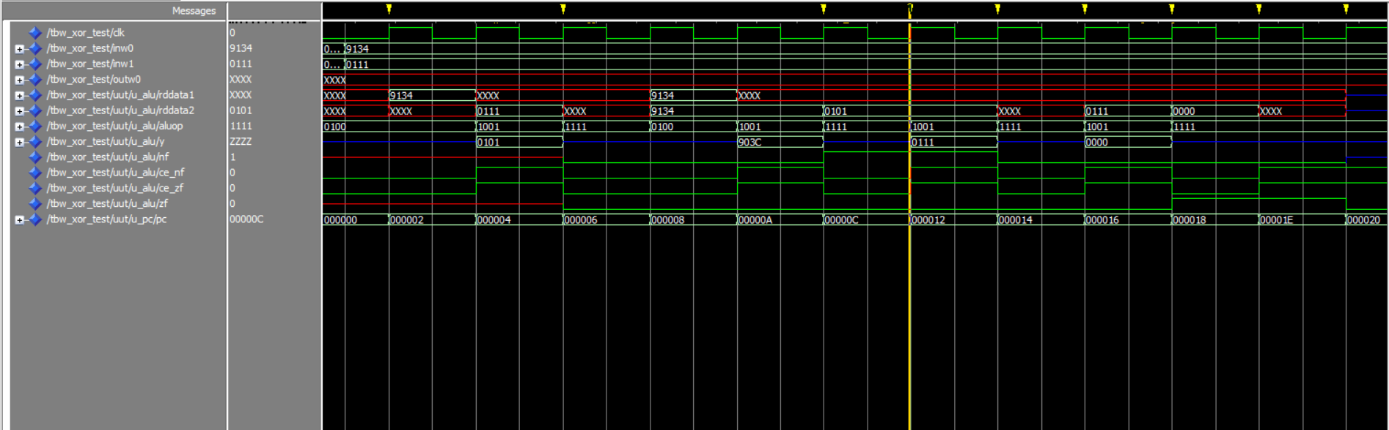
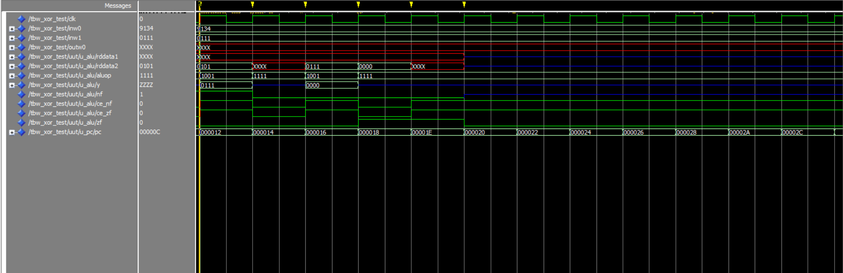

SUBB Wb,Ws,Wd
